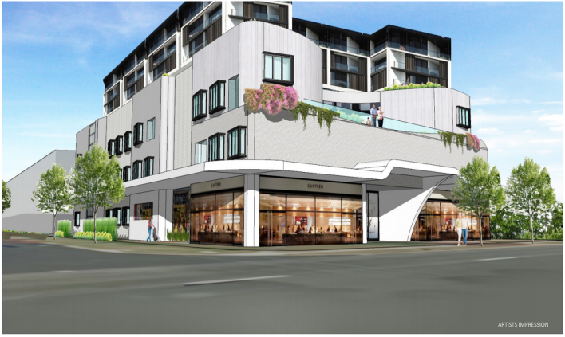

Positive Steps towards the Creation of a Coptic owned Nursing Home : Dr Magdy Shehata

Thanks to the Lord, without his guidance and blessings, it is not possible to achieve success. We can only plant, and water the plant, but the Lord makes it grow Corin 7:3.

With the blessings of our Lord Jesus Christ, the encouragement , support and enthusiasm of the Coptic community of Sydney, The Board of St Maurice Aged Care (SMAC), labored with enthusiasm, and dedication and managed to convert the Dream into Reality.
This is the taking of positive steps towards creating the first owned Aged Care Facility to look after the needs of our Coptic Community. This is in addition to the temporary arrangement and agreement with Ark Health Care for Bankstown facility.
Following the Fund raising Dinner Function , held 13 Nov, where all present expressed their support and enthusiasm for this well overdue Project, the Lord's blessings appeared in following positive steps:

1. SMAC purchased 3 adjacent Houses, total site 2080 m2. It is situated @ 200 m from Blacktown Railway Station, and Shopping Centre

2. The Site is zoned to allow 6, and may be 7 stories. The intention is to have 3 levels of Aged Care, with the remainder for Units to assist pay/ reduce the Cost of the Aged Care Facility below

3. SMAC applied to the Comm Gov. for 84 Bed Licences

4. SMAC applied for a Gov grant to assist in the Construction costs

The blessing of the Lord is working effectively. Your enthusiastic and devoted support is now most needed, and as St Paul said " I can do every thing in Jesus who strengthen me "
The Project is large, and in order to own our Coptic facility, your prayers and financial support, to convert the dream into a reality is now most needed
Pl visit : www : stmauriceagedcare.com.au
Donations : Comm Bank BSB 062136 ACC 10362649
Enquiry : Ramy 0431290470 Suzy: 0413168000

